1)

I have attached the file below and mentioned the requirement as well.

Please have a look before the class and please explain me in the morning

session.

URL;

<http://financecalculator.jaguar.co.uk/jag/en/gb/xe_jscwl01b/quote>

Requirement:

How can we drag exactly deposit, duration and mileage.

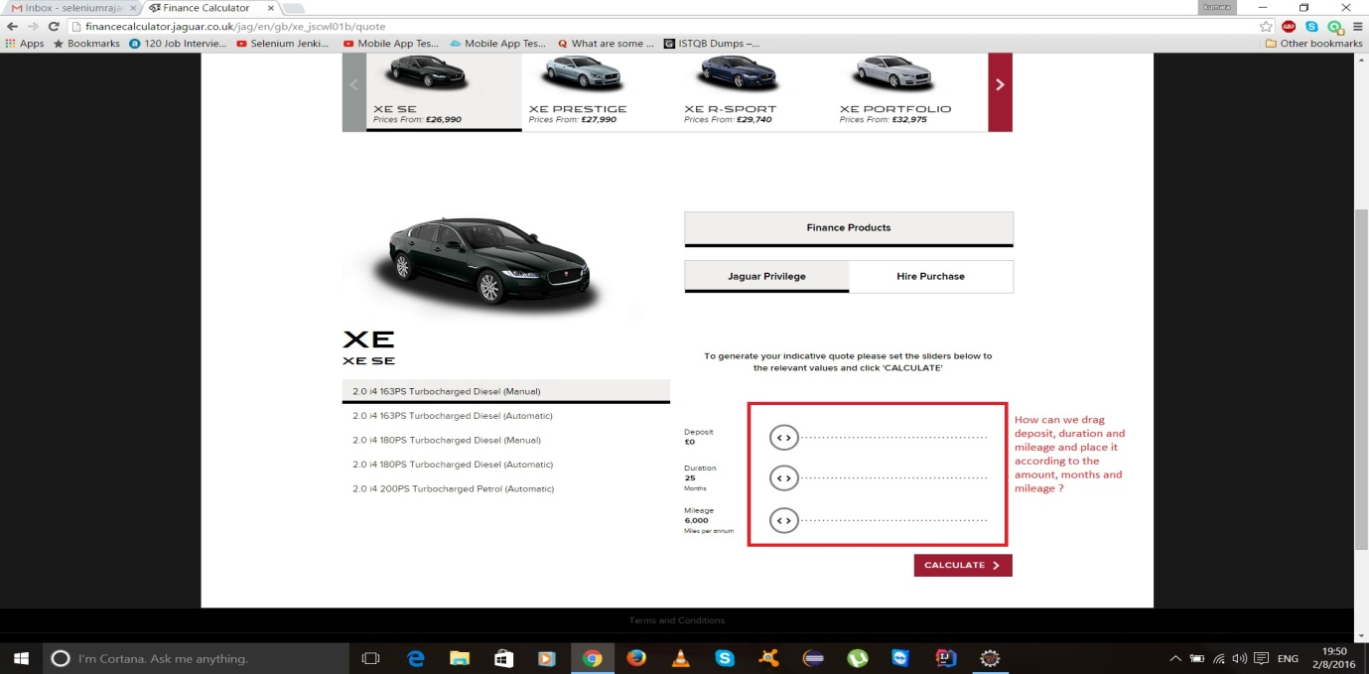

2)

I have attached the file below and mentioned the requirement as well.

Please have a look before the class and please explain me in the morning

session.

URL;

<http://www.jaguar.co.uk/index.html>

Requirement:

How can we click on the bar one by one to see all the images.

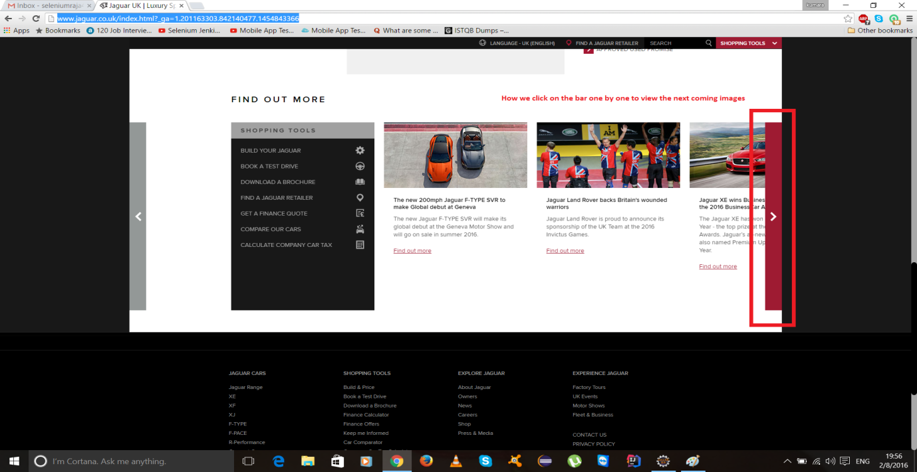

3)

I have attached the file below and mentioned the requirement as well.

Please have a look before the class and please explain me in the morning

session.

URL;

<http://www.jaguar.co.uk/index.html>

Requirement:

How to get text from the locations XE, XF, XJ, F-Pace, F-Type and Approved

Used. I have tried it, but got output in different way.

\*Code in Tool:\*

System.setProperty("webdriver.chrome.driver", "D:\\chromedriver.exe");

WebDriver driver = new ChromeDriver();

driver.manage().window().maximize();

driver.get("<http://www.jaguar.co.uk/>");

Thread.sleep(4000);

for (int i=1;i<=6;i++)

{

WebElement text =

driver.findElement(By.xpath("/html/body/div[4]/article/section/div["+i+"]/div[1]/h2

"));

text.getText();

System.out.println(text);

WebElement ima =

driver.findElement(By.xpath("/html/body/div[4]/article/section/div["+i+"]/a/img

"));

ima.click();

Thread.sleep(4000);

driver.navigate().back();

}

Thread.sleep(5000);

driver.close();

\*Output:\*

[[ChromeDriver: chrome on XP (aec73f37a4b85a54e7ac756faafcc875)] -> xpath:

/html/body/div[4]/article/section/div[1]/div[1]/h2 ]

[[ChromeDriver: chrome on XP (aec73f37a4b85a54e7ac756faafcc875)] -> xpath:

/html/body/div[4]/article/section/div[2]/div[1]/h2 ]

[[ChromeDriver: chrome on XP (aec73f37a4b85a54e7ac756faafcc875)] -> xpath:

/html/body/div[4]/article/section/div[3]/div[1]/h2 ]

[[ChromeDriver: chrome on XP (aec73f37a4b85a54e7ac756faafcc875)] -> xpath:

/html/body/div[4]/article/section/div[4]/div[1]/h2 ]

[[ChromeDriver: chrome on XP (aec73f37a4b85a54e7ac756faafcc875)] -> xpath:

/html/body/div[4]/article/section/div[5]/div[1]/h2 ]

[[ChromeDriver: chrome on XP (aec73f37a4b85a54e7ac756faafcc875)] -> xpath:

/html/body/div[4]/article/section/div[6]/div[1]/h2 ]

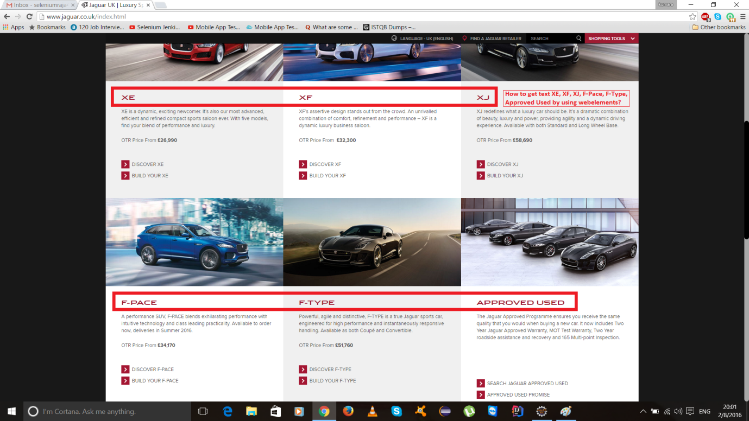

Please explain me in the morning session about the requirement.

URL;

<http://www.jaguar.co.uk/>

Requirement:

How can we get the whole page width and height. How can we find the images

width and height using Selenium. How can we get the information from images

using Selenium with Java.